**Keep America Beautiful**



**Cougar Student Technologies**

**Alex Garcia, Arianna Camino, James Hanlon, Oscar Castellanos, Vinny Vue**

**Table of Contents**

**Executive Summary** **3**

**Application Development** **4**

Business Context 4

Project Proposal 4

Requirements Matrix 6

**Project Management** **8**

Product Breakdown Structure 8

Work Breakdown Structure 9

Gantt Chart 10

Cost Tracking Chart 12

**Team Information** **13**

Team Resumes 15

**Group Timesheets** **21**

## 

### Executive Summary

#### 

**Date** : 4/11/2021

**To** : Dr. Wesley Schultz

**Cc** : Dr. Shaun-Inn Wu, Director of Projects

**From**: Oscar Castellanos, Cougar Student Technologies Team

**RE**  :Phase #3

**Overview**

In Prototype 1 we successfully created a python script that queries an input for an address or coordinate and retrieves the image from the Google Street View API along with its metadata such as the date and address in which the photo was taken, the latitude and longitude, the image ID and the status of the requested image. Currently we can only display a single image at a time and the image and metadata is saved on a local device. With further discussion we plan to research ways to automate this process given a defined region.

**Next Phase:**

For the next phase of the project, we are going to dive more into OSMnx. This will allow our program to retrieve multiple images from a single location and obtain multiple coordinates within a city or region. The estimated cost of the next phase will be approximately $2,900.

**Time and Cost:**

The time and cost of the third phase between a team of five CST members has totaled 140 hours at a rate of $25.00/hour, yielding a total amount of $3,500. The remaining two phases will be projected to cost $3,825. The total cost of the project approximates to $10,075 and is subject to change as we continue working on the project.

Enclosed: Report #3

_________________________________________ __________

Dr. Wesley Schultz, Acceptance Print & Signature Date

### 

### 

### 

### **Application Development**

#### **Business Context**

Keep America Beautiful is a non-profit organization that aims to end littering, improve recycling and beautify communities through various programs and initiatives. The organization is supported by community-based affiliates, volunteers, corporate partners, municipalities, and elected officials. Previous partners have worked with Google Street View Static API for pulling Google Street Images using python scripts.

**Business Problem**

Keep America Beautiful is seeking for a solution to obtain images from Google Street View to be processed by an algorithm that identifies litter. They also require the solution to be automated to allow for larger scalability and efficiency.

#### **Project Proposal**

Our team will create a system for pulling these Google street images for a designated area given the city, region, community, county, etc. The objective is to design a program that will automate the process of obtaining images for detecting litter. So that once the system has been developed, we can then pass these images through the ML algorithm to get their litter scores.

**Deliverables**

* A system that will process coordinates to retrieve images of any given location or given area.
* Any detailed attempts of third-party tools to automate this process. We are going to first begin with OSMNx as suggested from previous groups and report our attempts.
* We would like to retrieve any image metadata rendered by our system.
* The client should expect to receive a word document report of the prototype in their email inbox which may include a website to deploy the script seamlessly.

**Measures of Success**

Phase 1:

* Identify project requirements and needs from client and report Meeting Minutes back to understand project workers know what to accomplish.

Phase 2:

* Finalize project requirements and needs from client. Meeting JAD 2 with the Client and Director to finalize questions, confusion, must haves and nice to haves.

Phase 3:

* Begin Prototype 1 with understanding of last year's projects and direction that can lead us into making an automated program to request an image of a single location from Google Street View.

Phase 4:

* Improve the original program by requesting multiple images of a single location.
* Implement the image capturing process along a street with defined distances between each coordinate or obtain a random sampling of coordinate points from a city or a region defined by a radius.
* Create a website that will allow an input for a location to run the program. It will include an interactive map and will display any results for a user-friendly interface.

Phase 5:

* Presentation of the final project with outcomes and report findings.
* A deployable prototype the client can readily use.
* Future implementation suggestions and manuals to provide groups after us who would like to utilize the script.

**Visual Representation**

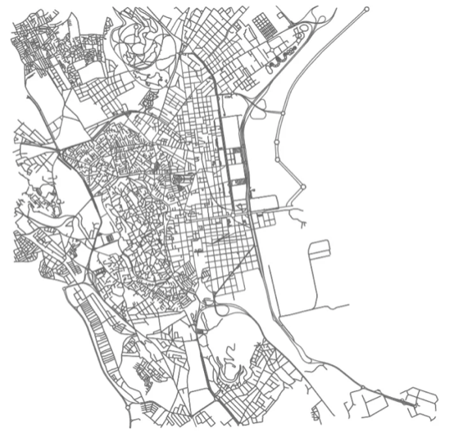 *OSMnx detecting all streets in a city.*

OSMNx was a great tool to use to retrieve metadata about multiple nodes that we could potentially feed into our image and data retrieval system to retrieve an image . The challenge was that it limited the amount of data we could extract because OSMNx primarily provides vertice coordinates.

#### Requirements Matrix

|  |  |  |  |  |
| --- | --- | --- | --- | --- |
| **Req. #** | **Requirement** | **Description** | **Task #** | **Implemented** |
| 1 | User requested region with a fixed boundary. | * A defined location will help restrict the number of extracted images. After the requirement is satisfied, we will determine the search boundaries by either using a circle or collecting images between two nodes. (ex. given a city or street name). | 62 | No |
| 2 | Collect  street view Google images | * Obtaining and downloading google street images to a specified folder. The search will execute to retrieve automated google images. | 63 | Yes |
| 3 | Collect  Metadata | * Obtain and download metadata from each photo rendered from the GST images. | 63 | Yes |
| 4 | Removing unusable images | * Removing insignificant images will improve processing and add distance to our search. Only collecting images that show sidewalks and street asphalt view. Removing images such as the sky and buildings. | 81 | No |
| 5 | Use OSMnx to define streets and regions | * Use OSMnx to define streets within a city to easily grab latitude and longitude points for the python script to display/capture the image. | 82 | No |
| ~~~~~ |  | *Listed below are nice-to-have requirements* |  | ~~~~~~~~~~ |
| 6 | Create a user interface | * Create a website so that users that are not familiar with code can utilize the script as a tool. * Navigation bar and display of results. | 94 | No |
| 7 | Adding Maps Embed to web page | * An interactive map from Google Maps Embed API will be implemented on our website. The map will add a user-friendly interface. | 95 | No |

### 

### 

### **Project Management**

#### 

#### Product Breakdown Structure

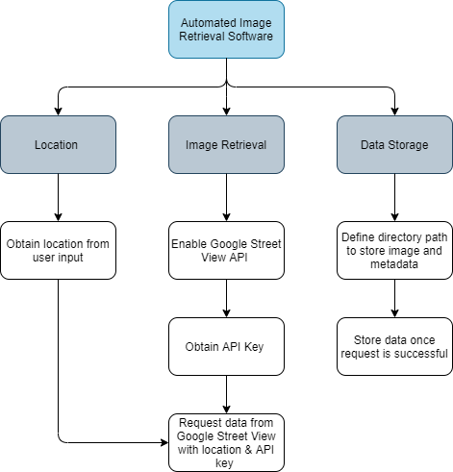

#### Work Breakdown Structure

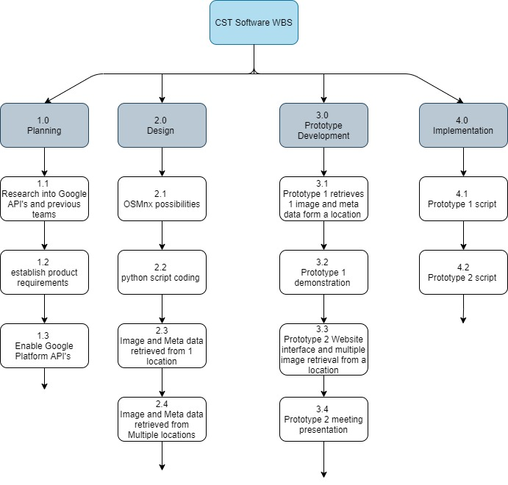

#### **Gantt Chart**

### 

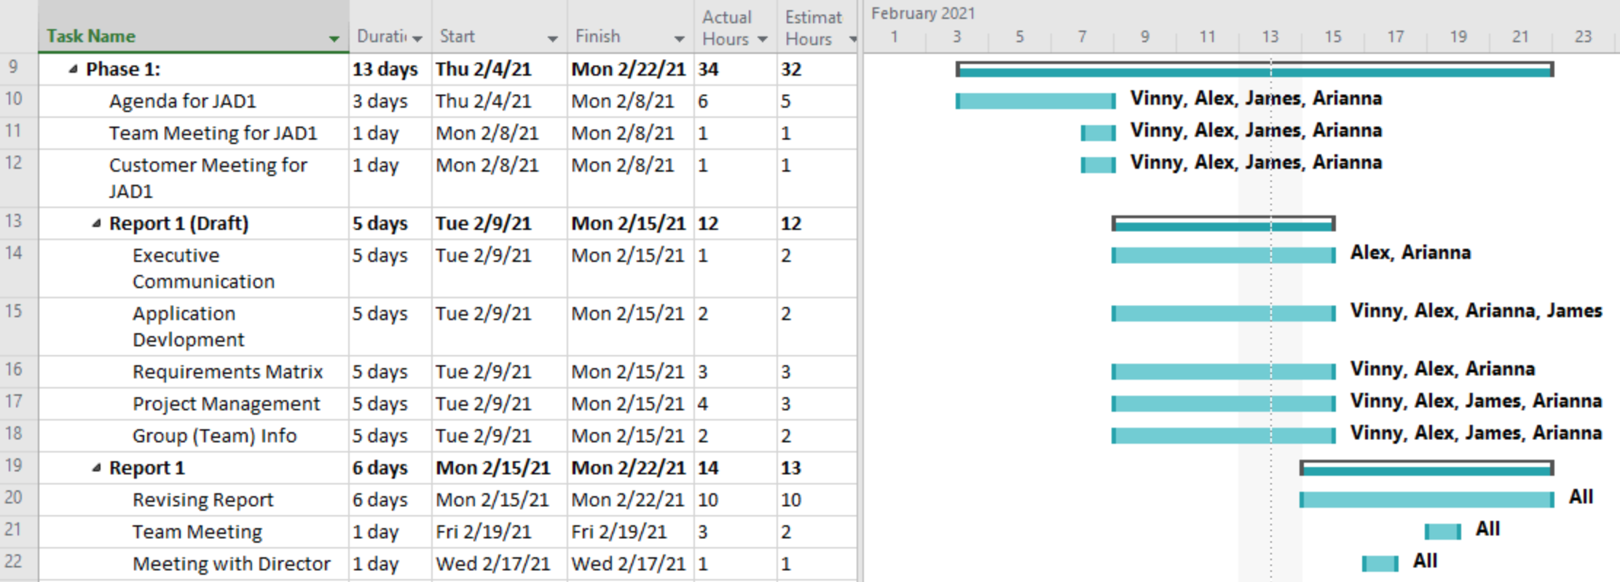

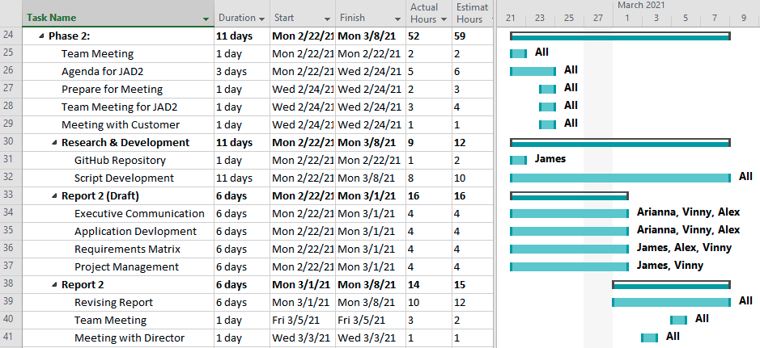

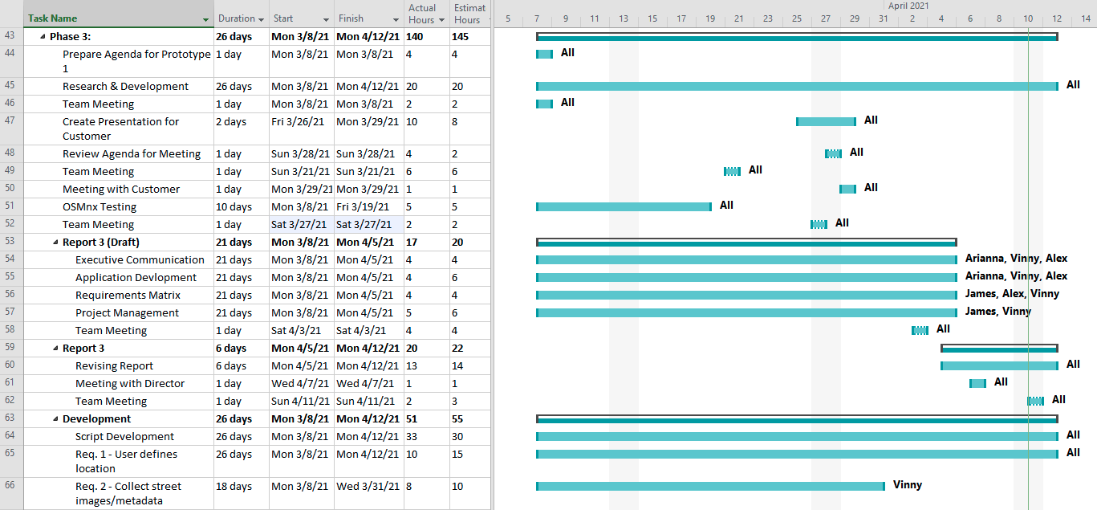

#### 

#### 

#### **Cost Tracking Chart**

We will assume an hourly rate of $25.00 per hour for this project. We assessed that this rate is appropriate for the project scope and requirements but is negotiable with the client if desired. Below is a chart outlining estimated and actual costs for each phase of the project as well as our total accumulated costs compared to our estimated costs. All values are represented in dollars.

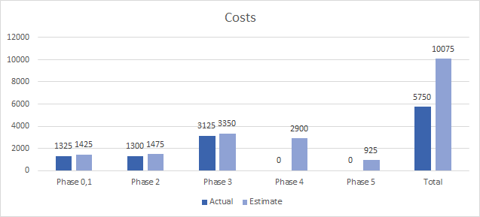

**Resources**

Our team will be supplying the following resources for this project:

* Our work and research into previous team projects and additional resources used.
* All images collected for the project.
* An updated document for each phase of the project.
* A final report detailing our process and updates throughout the project.

Our team will need to be supplied the following resources from the client:

* Reports from previous teams for reference
* Approval on our project solutions
* Future meeting availability

### **Team Information**

As a team, we expect to have all team members contribute knowledge, opinions, and time consistently to fulfill weekly goals throughout the life of the project. Team members will conduct themselves professionally, respectfully, and cordially among each other and with Dr. Schultz. Collaboration among all team members will play a key role in the team’s success.

|  |  |
| --- | --- |
|  | **Oscar Castellanos**  Project Leader  Cell: 760-693-6704  Email: Caste055@cougars.csusm.edu  **Experience**: Experience leading previous groups and managing a team! |
|  | **James Hanlon**  Project Manager  Cell: 760-330-1910  Email: Hanlo007@cougars.csusm.edu  **Experience**: Familiar with Google Maps and Street View but no experience implementing API’s. Very good communicator, have led students and children for many years with previous roles. Can resolve issues and conflicts if they arise, as well as identify the end result the customer desires. |
|  | **Arianna Camino**  Multimedia Programmer  Cell: 760-497-5890  Email: Camin003@cougars.csusm.edu  **Experience**: No previous experience with machine learning or Google Maps API, some experience with AWS and databases, plenty experience communicating and working with groups of all kinds. |
|  | **Alex Garcia**  Documentation & Training  Cell: 951-358-2990  Email: Garci825@cougars.csusm.edu  **Experience**: No experience or background in Google Map API, machine learning, or Python. Experience in collaborating with others in achieving the best possible outcome of any project or service. |
|  | **Vinny Vue**  Programmer/Database Administrator  Cell: 858-245-0618  Email: vue003@cougars.csusm.edu  **Experience**: No previous experience with Google Map API or machine learning. Familiar with programming languages and web design along with databases. As well as working and collaborating in a team environment. |

#### Team Resumes

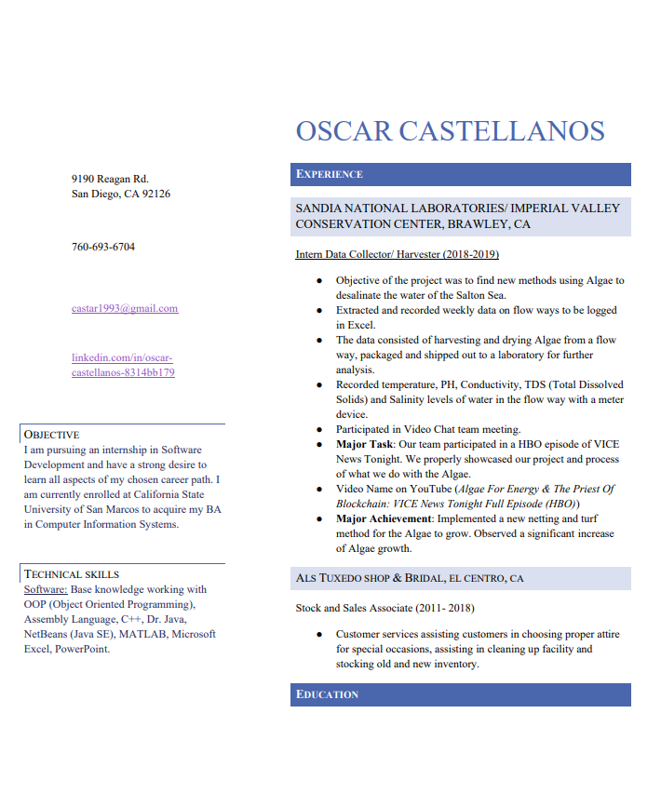

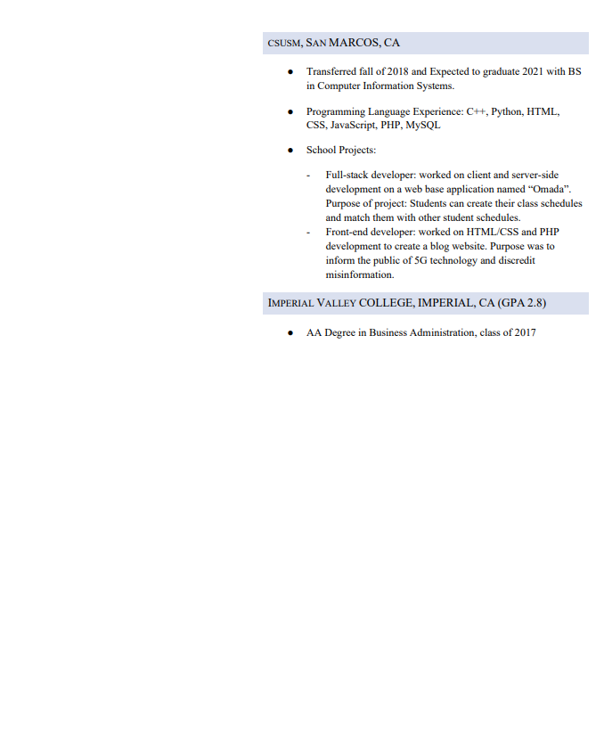

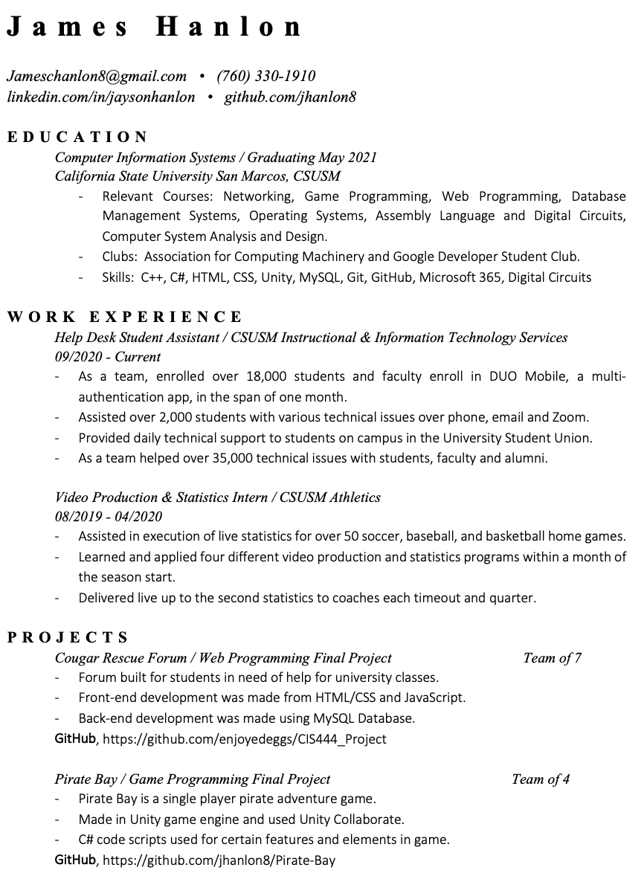

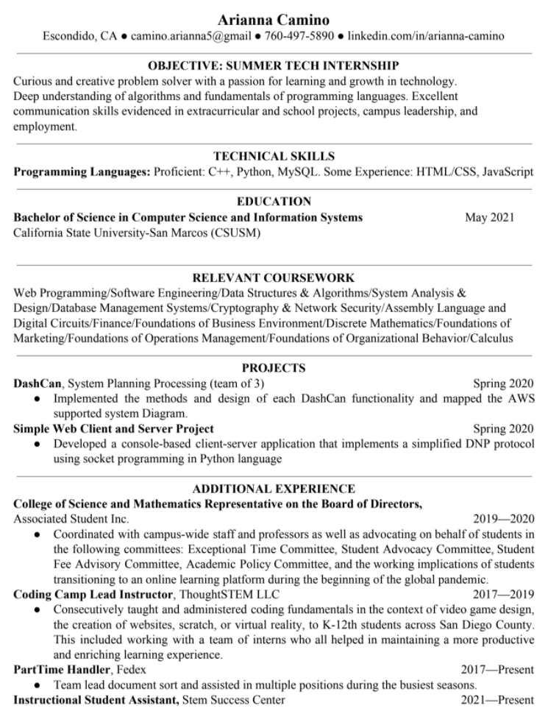

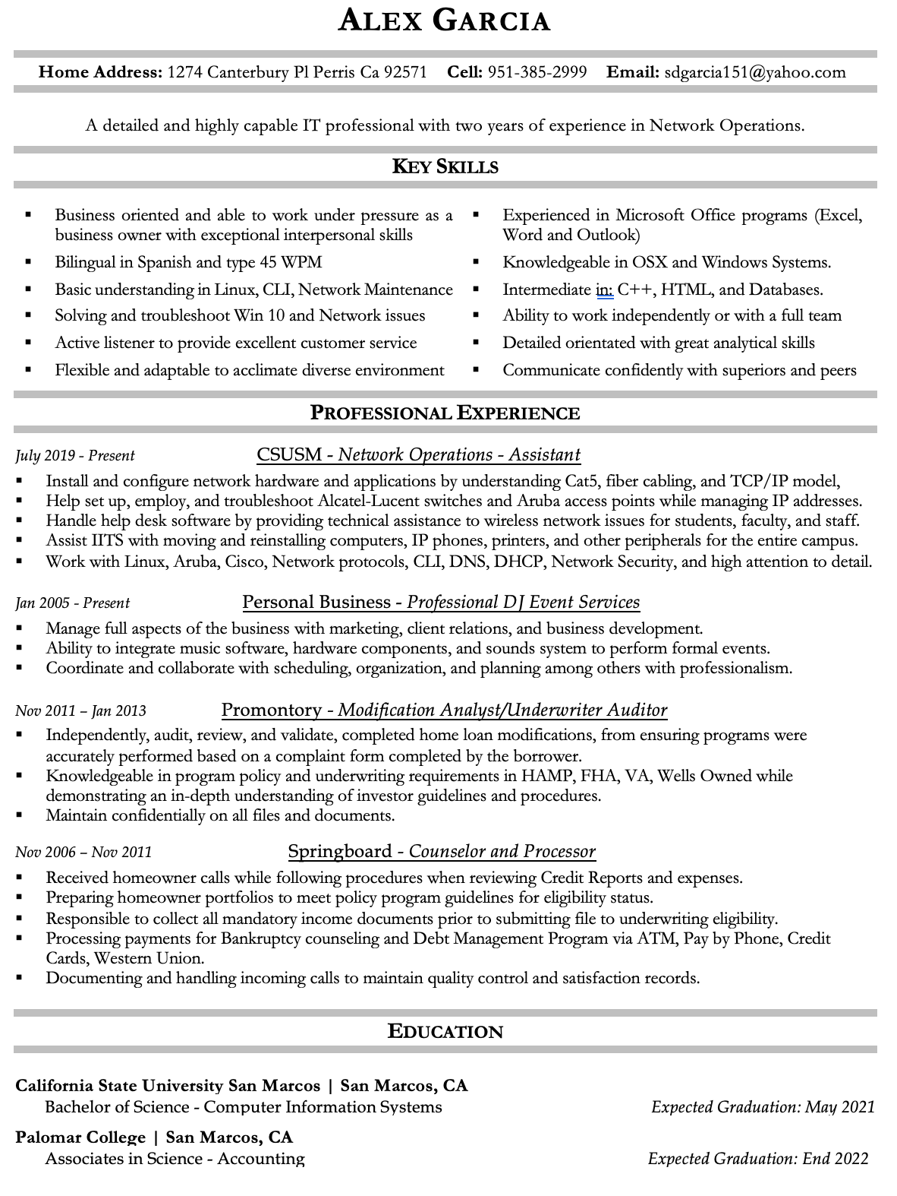

#### 

#### 

### Group Timesheets

**Oscar Castellanos:**

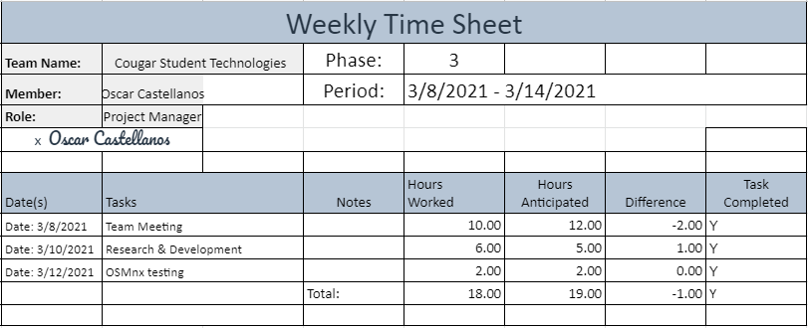

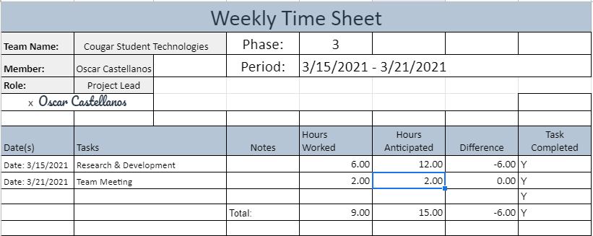

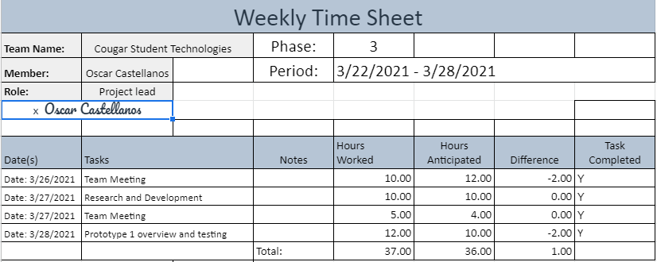

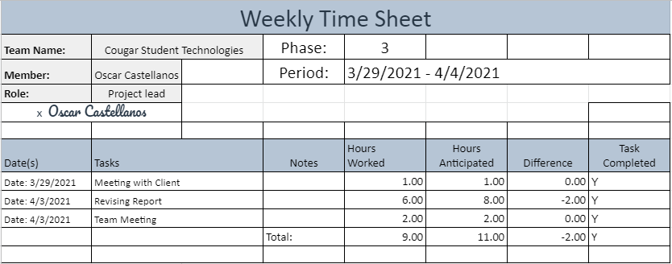

**James Hanlon:**

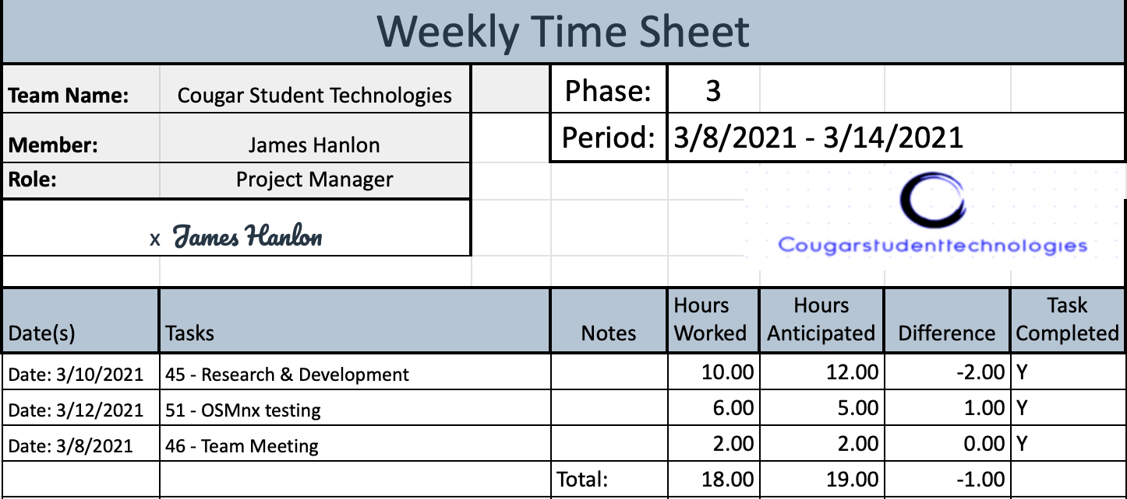

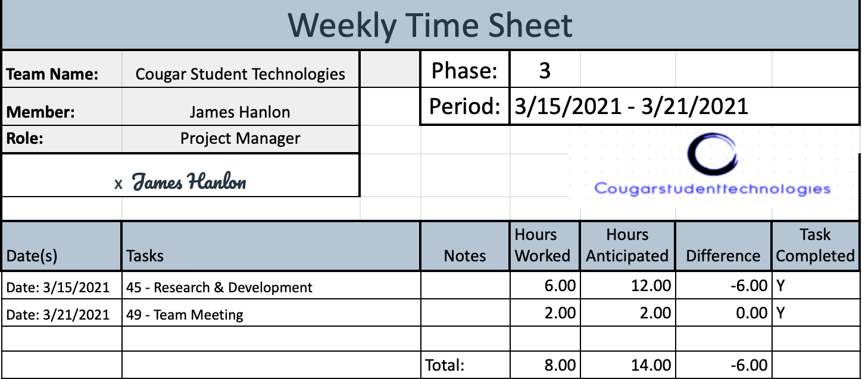

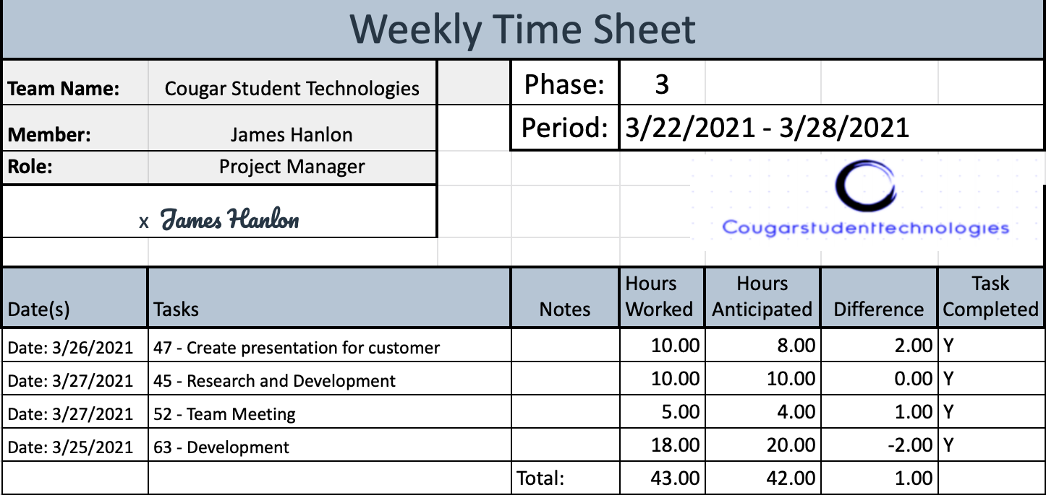

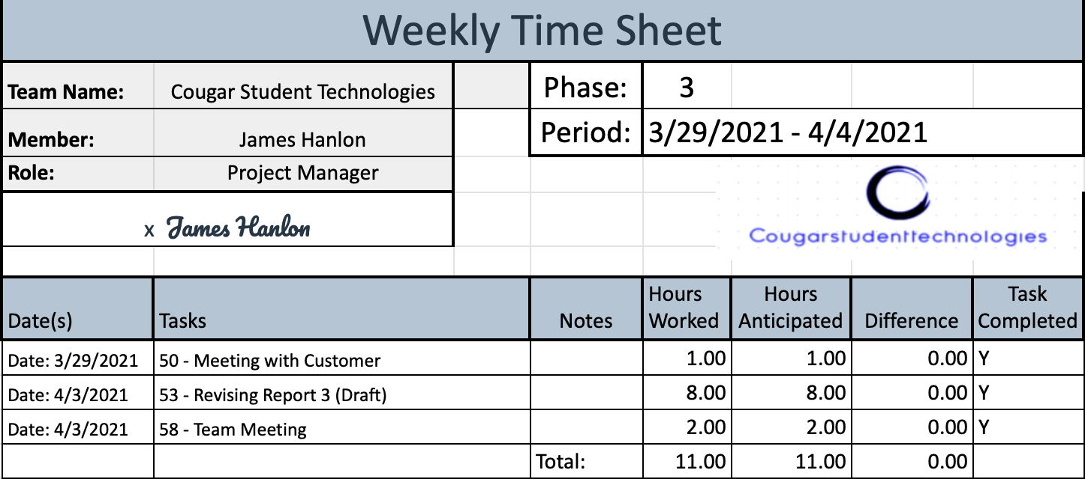

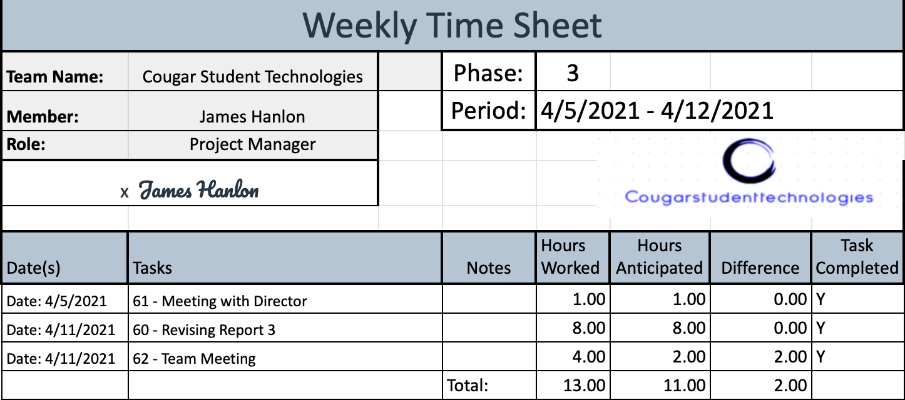

**Arianna Camino**

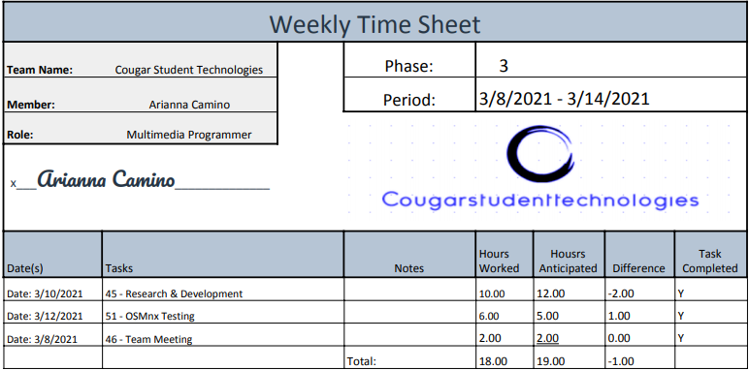

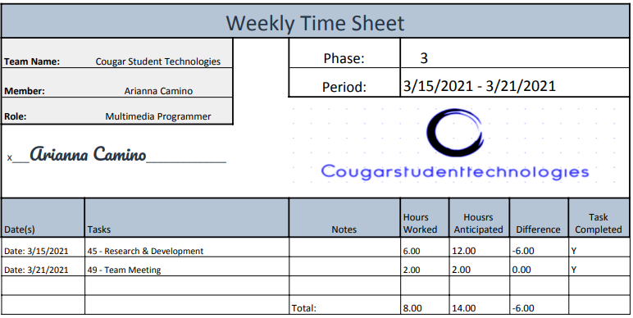

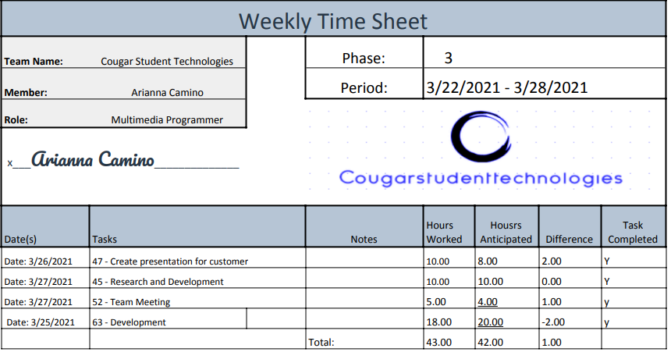

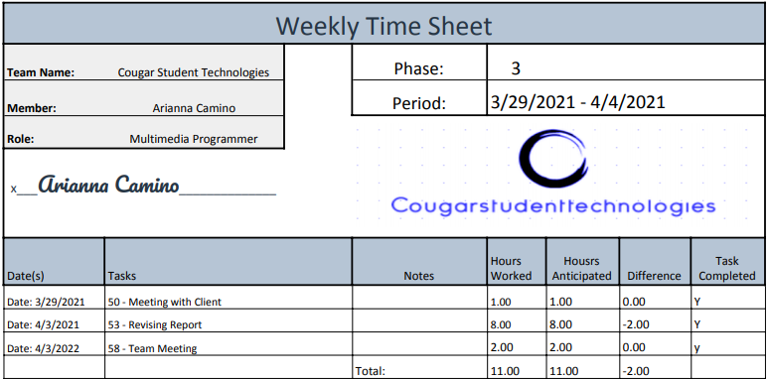

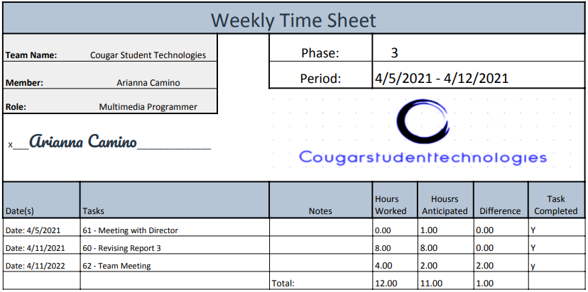

**Vinny Vue:**

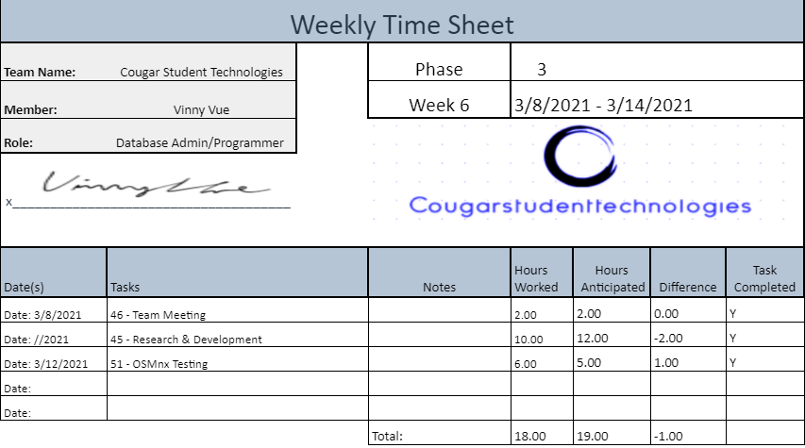

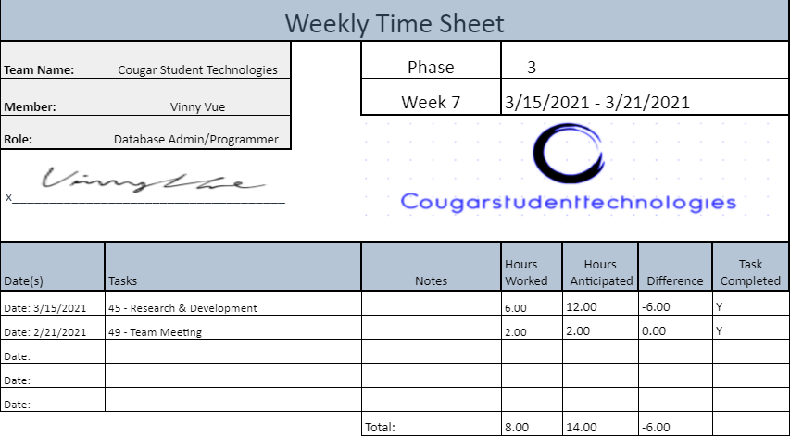

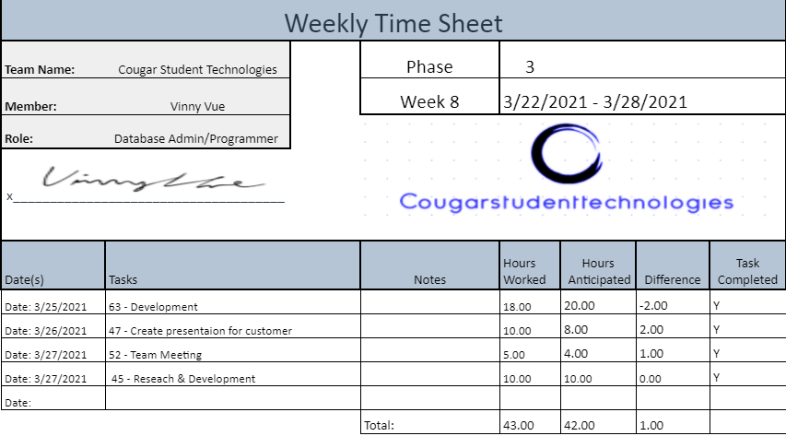

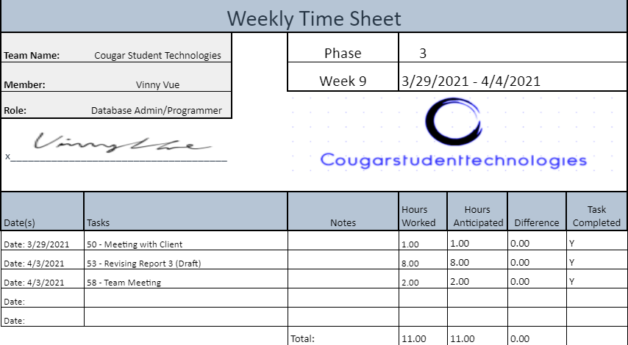

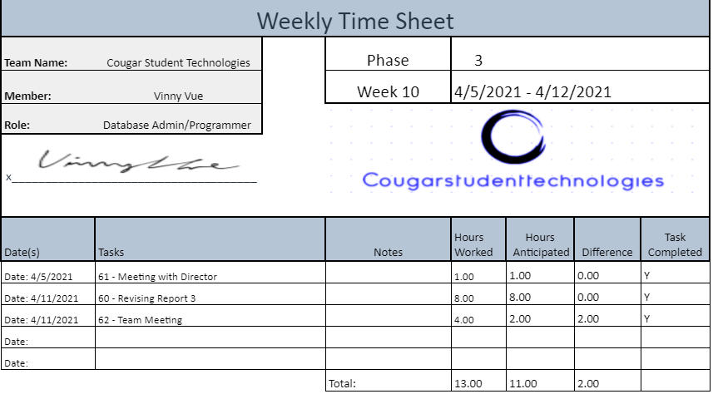

[Alex Garcia](mailto:garci825@cougars.csusm.edu):